Python and Deep Learning Programming

Name: Sri Devi Mallipudi ICP -1

Class ID: 20 StudentId: 16251191

**1. State differences between Python 2 and Python 3 version. Write a Python program to get the Python version you are using.**

Solution:

Python 3 is the latest version of the language. Python 3 was introduced to make the python easier to use and handle the strings. The main differences of python 2 and python 3 are:

**Print:** In Python 2, “print” is treated as a statement rather than a function whereas in Python 3, there is no need to wrap the text in parenthesis.

**Raising Exceptions:** Python 3 requires different syntax for raising exceptions. If you want to output an error message to the user, you need to use the syntax:

raise IOError(“your error message”) This syntax works in Python 2 as well. The following code works only in Python 2, not Python 3: raise IOError, “your error message”.

**Unicode Strings:** Python 3 stores strings as Unicode by default, whereas Python 2 requires you to mark a string with a “u” if you want to store it as Unicode.

**Program to get the Python Version:**

**Source code:**

import platform

print(platform.python_version())

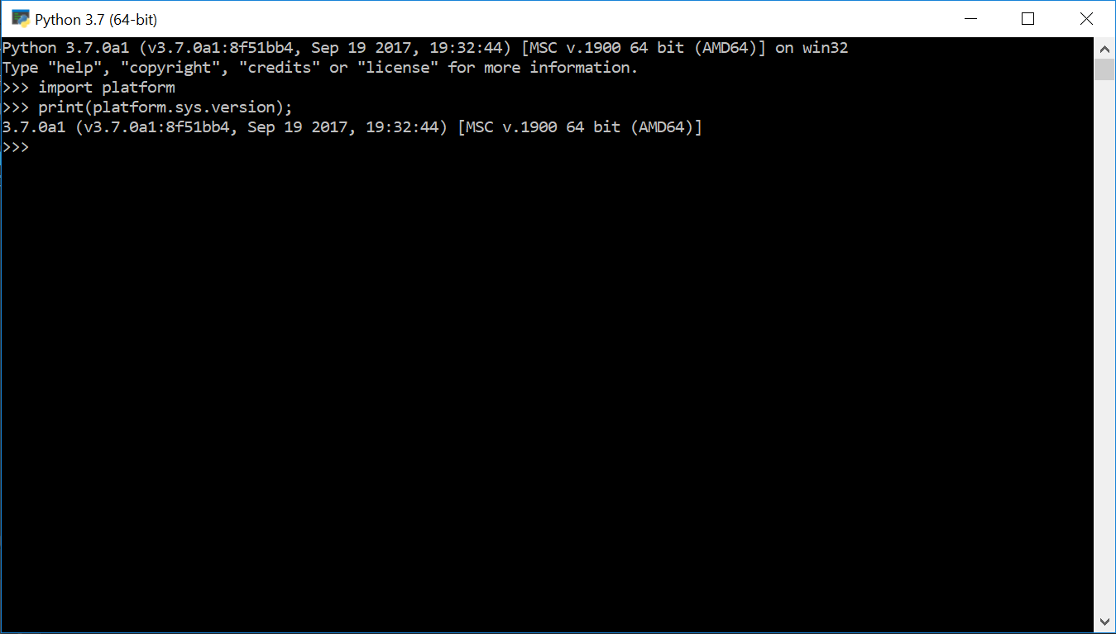

**2. Write a python program to**

**a. Take the user first name and last name and then print it in reverse order**

**Source Code:**

username = input("Enter your first and last name: ")

string_reversed = username[-1::-1]

print(string_reversed)

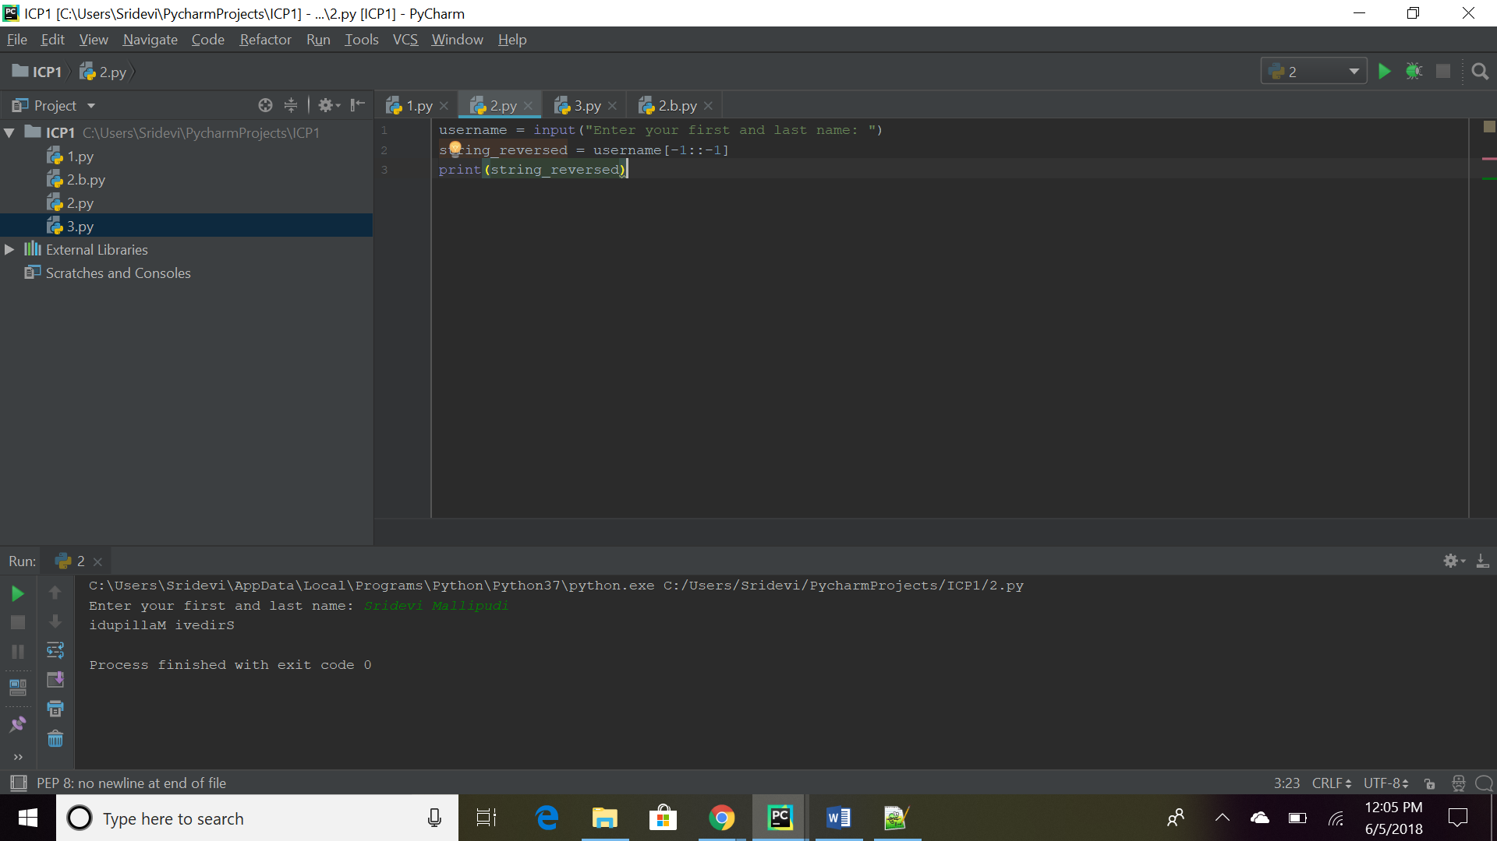

**b. To take two numbers from user and find their quotient and remainder. Print it.**

**Source code:**

a=int(input("Enter the first number: "))

b=int(input("Enter the second number: "))

quotient=a//b

remainder=a%b

print("Quotient is:",quotient)

print("Remainder is:",remainder)

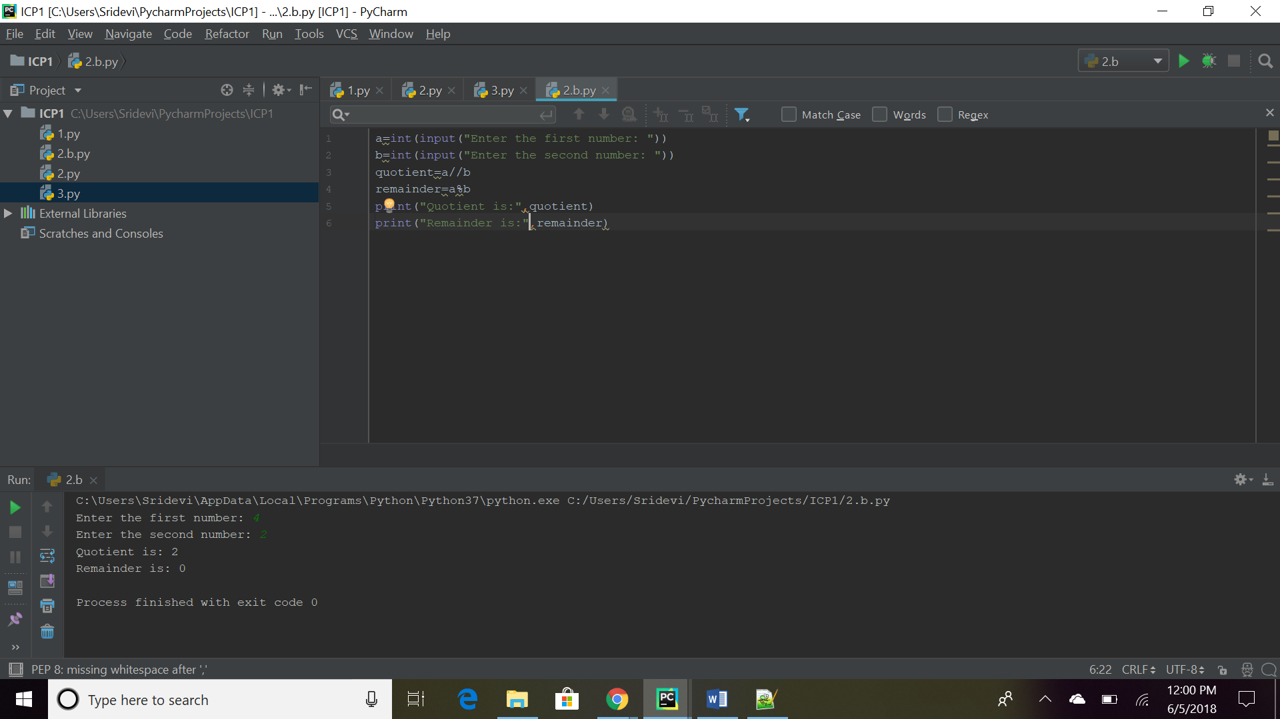

**3.Write a python program to**

**This is a number guess exercise. First pick a random digit via program i.e.**

**0,1,2,3,4,5,6,7,8,9**

**Ask the user to guess the digit randomly picked by your program. Then print whether the number guess by the user is exactly matched or below the random number or above the random number. Also, your program should explain the rules of this number guess game to the user.**

**Source Code:**

import random

while 0==0:

n= random.randint(0,9)

print('guess', n)

n1=input("Enter a guess")

guess=int(n1)

if guess == n:

print("Your answer is PERFECT!! Congratulations!!")

break

elif guess > n:

print("Your answer is high than required")

else:

print("Your answer is low than required")

